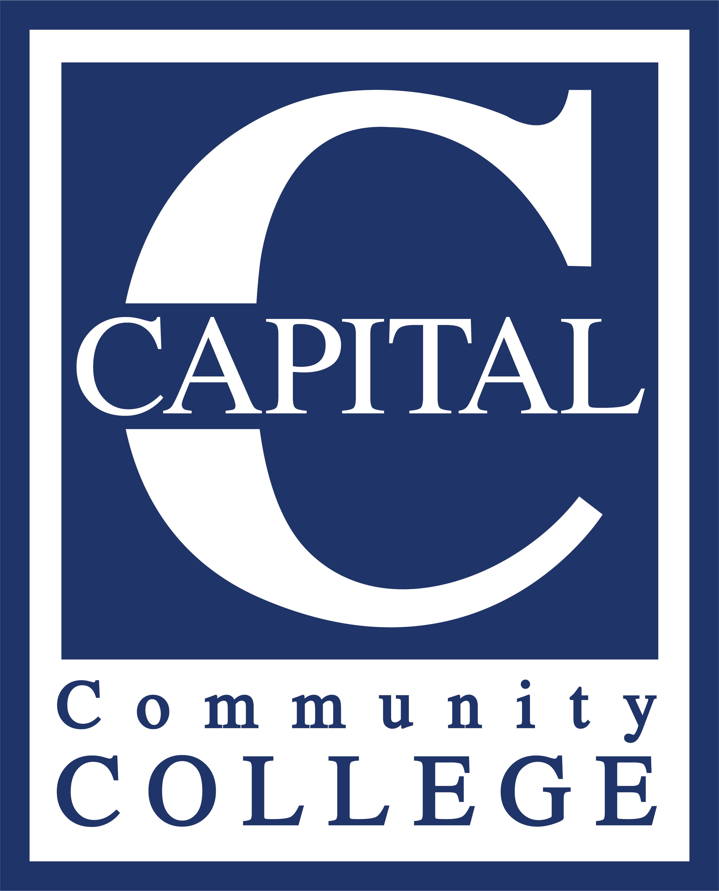
SOCIAL MEDIA REQUEST PROCEDURE – Updated 9.10.2021
As the college works to increase its social media footprint, the marketing department is receiving more requests to share content on our social media channels. This document will provide information on the best way to make a request as well as inform you of what documentation is needed in order to efficiently process said request. All social media requests should be sent to Vivian Nabeta at vnabeta@capitalcc.edu. Because additional planning and scheduling are required for social media your post may not be viewable until some time after your request has been submitted. Once your request has been reviewed, you will be contacted to discuss and/or be giving an approximate live date. If your request is time sensitive and social media is needed for promotional/awareness purposes, please contact Vivian as soon as possible.

Items needed for social media request submissions. Please review before submitting.
- Brief description of the activity/event. Please remember to include dates, location(s), names of people and/or awards, if relevant.
- Photos and/videos, if relevant and/or needed
- Social media information for any partners, individuals, or groups that need to be tagged in post(s).
- Refer to the example request for additional guidance.

Questions?
Feel free to contact Vivian.

Example request – For review
Hi Vivian
If possible, would you please post something about the Hidden Figures/Panel Discussion event that we had yesterday?
The names of the panelists in the last picture (Hidden Figures Panelists Group Photo) are in order from left to right:
Tanica Walcott-Thompson, ASC Chemistry Tutor
Dr. Cleo Rolle, Assistant Professor of Biotechnology, CCC
Dr. Carla Parker-Athill, Assistant Professor of Biology, Connecticut College
Racquel Walker, Data Center IT Analyst, Pratt and Whitney
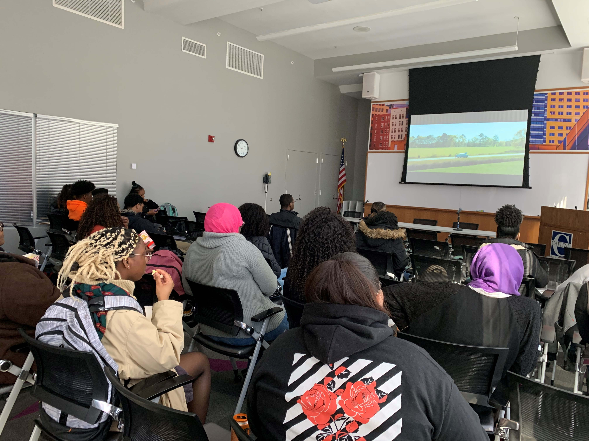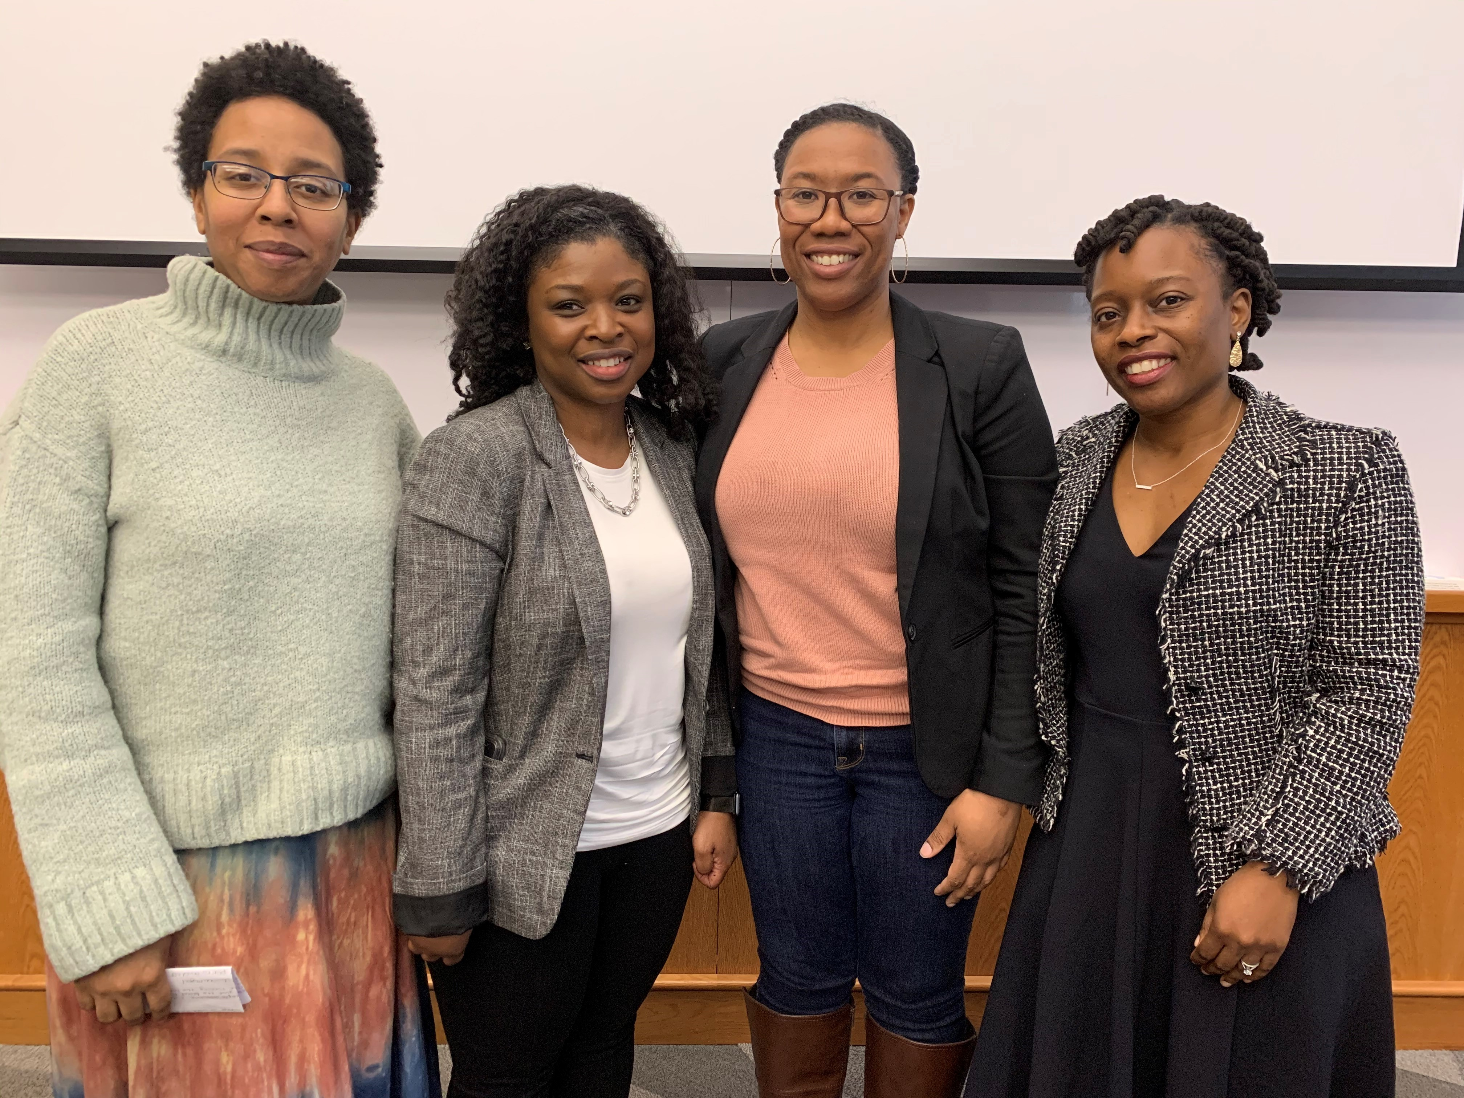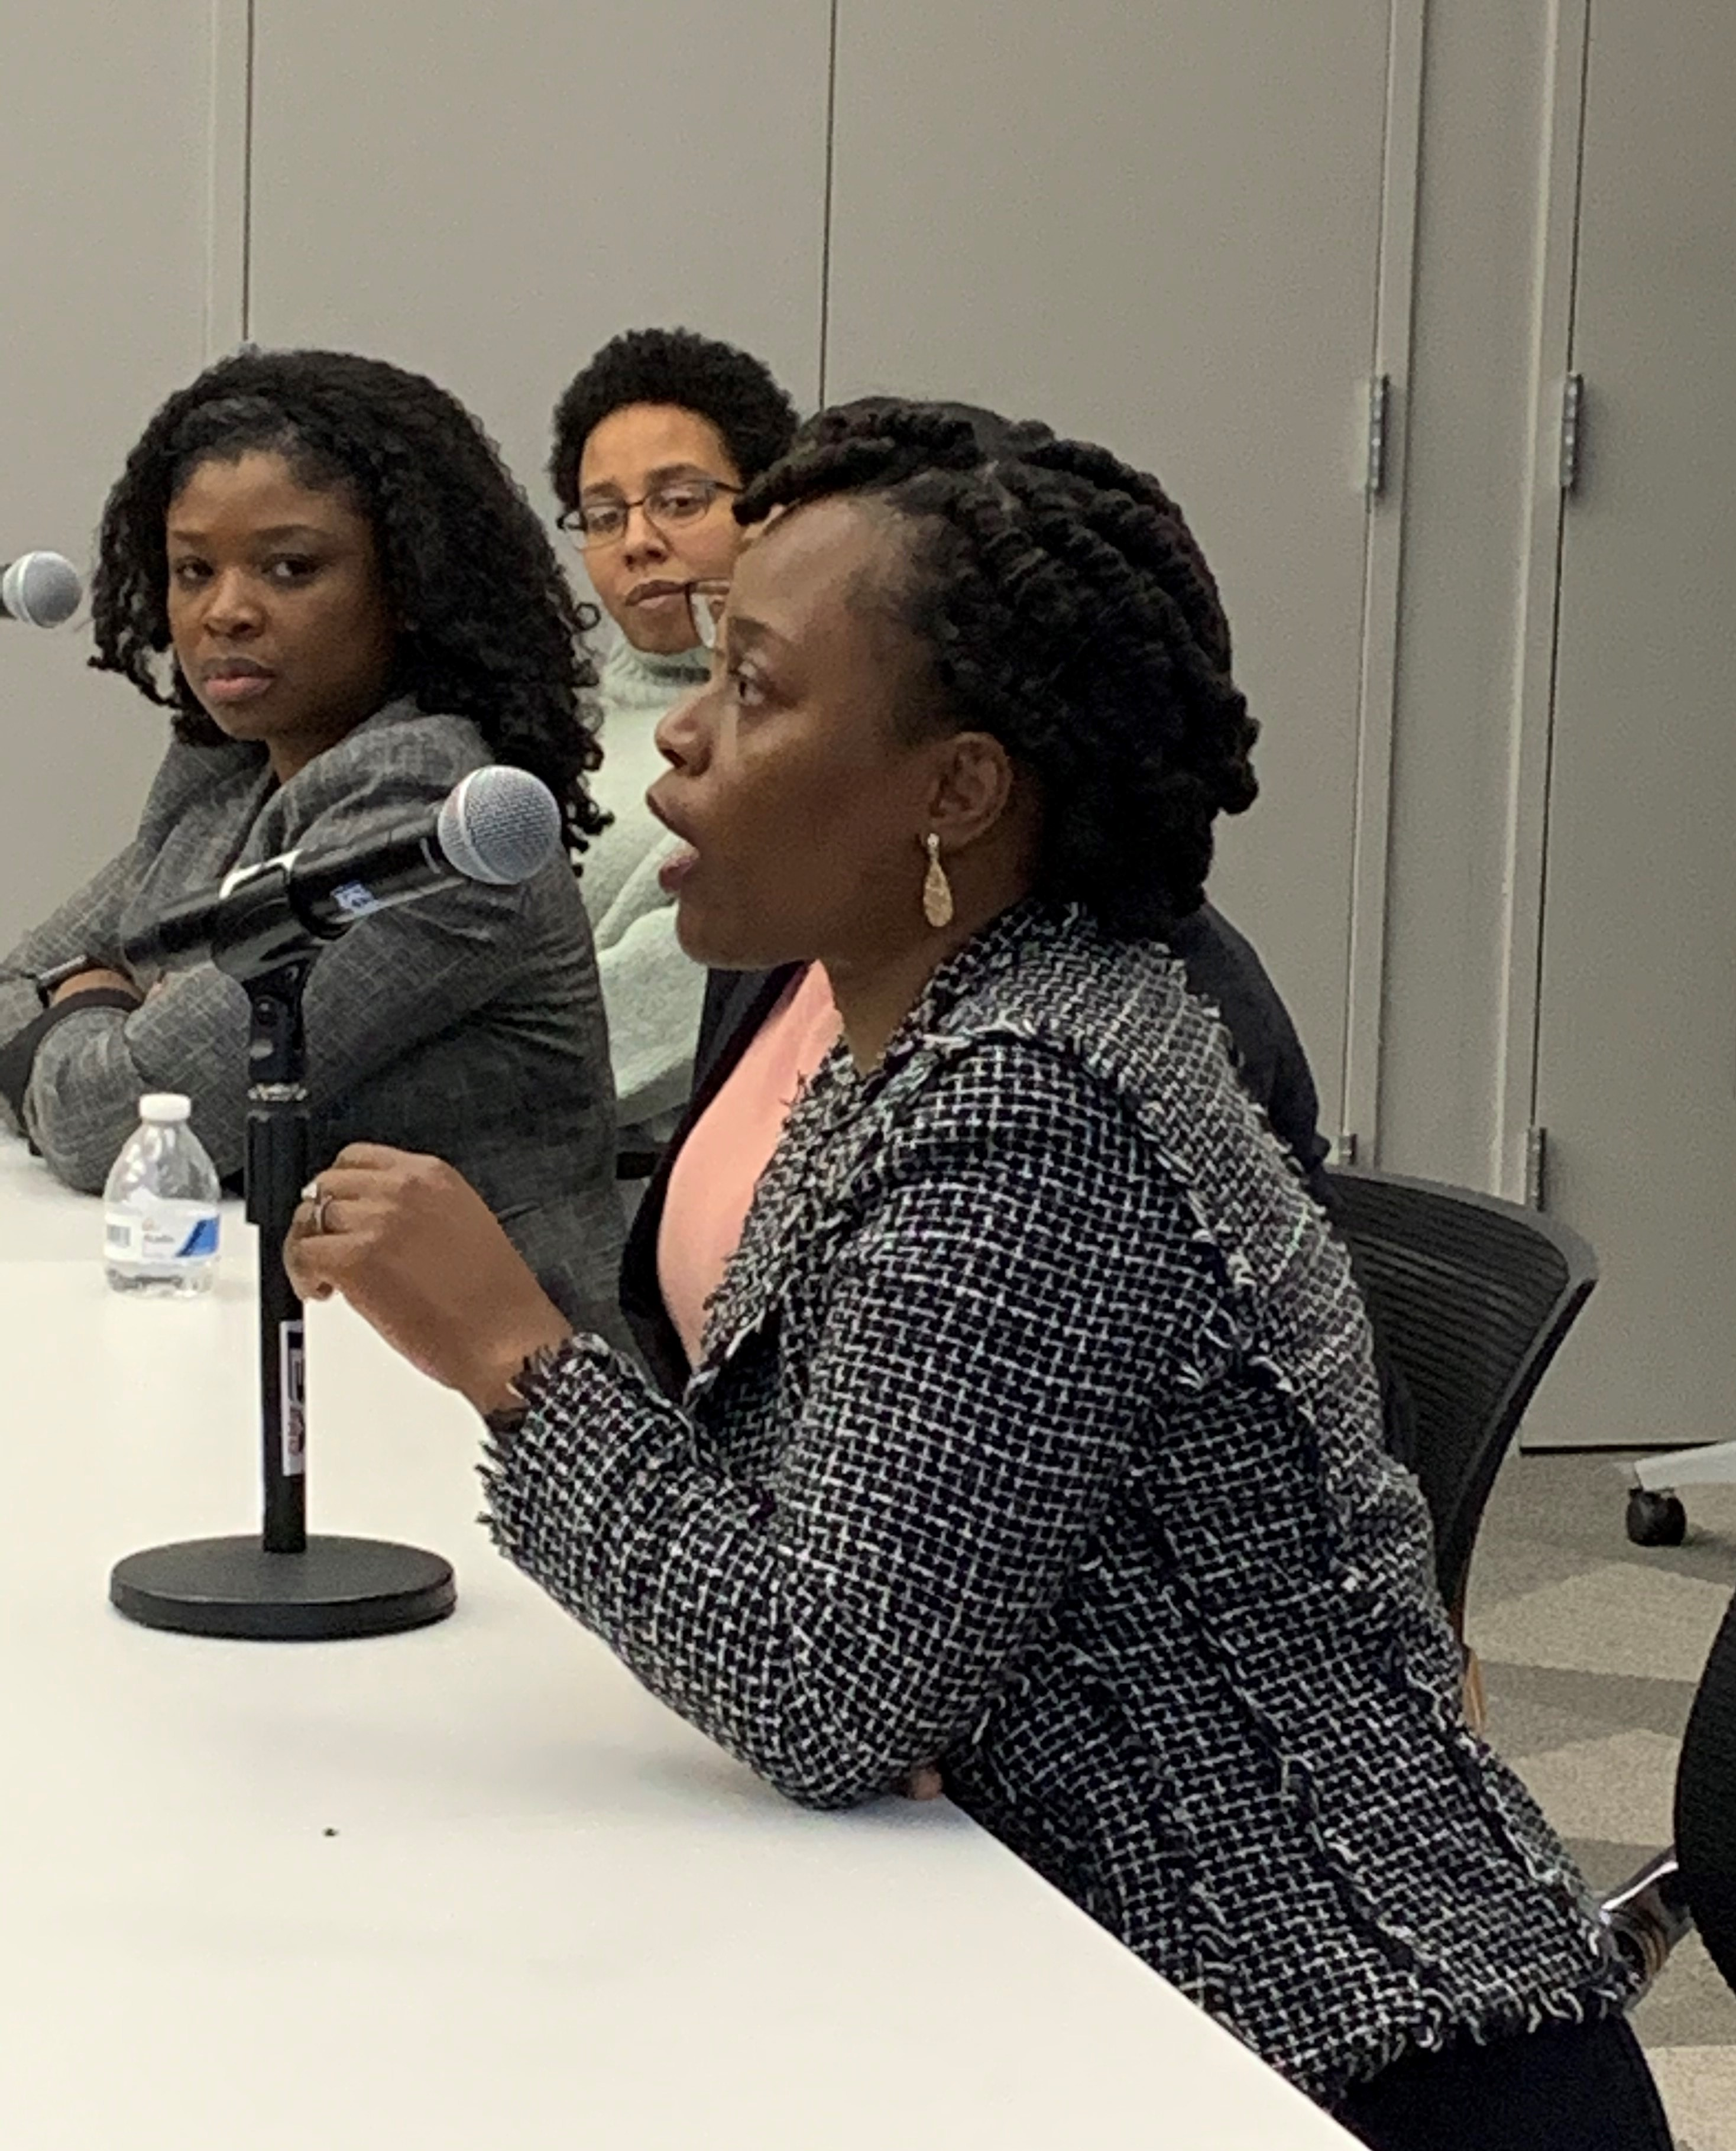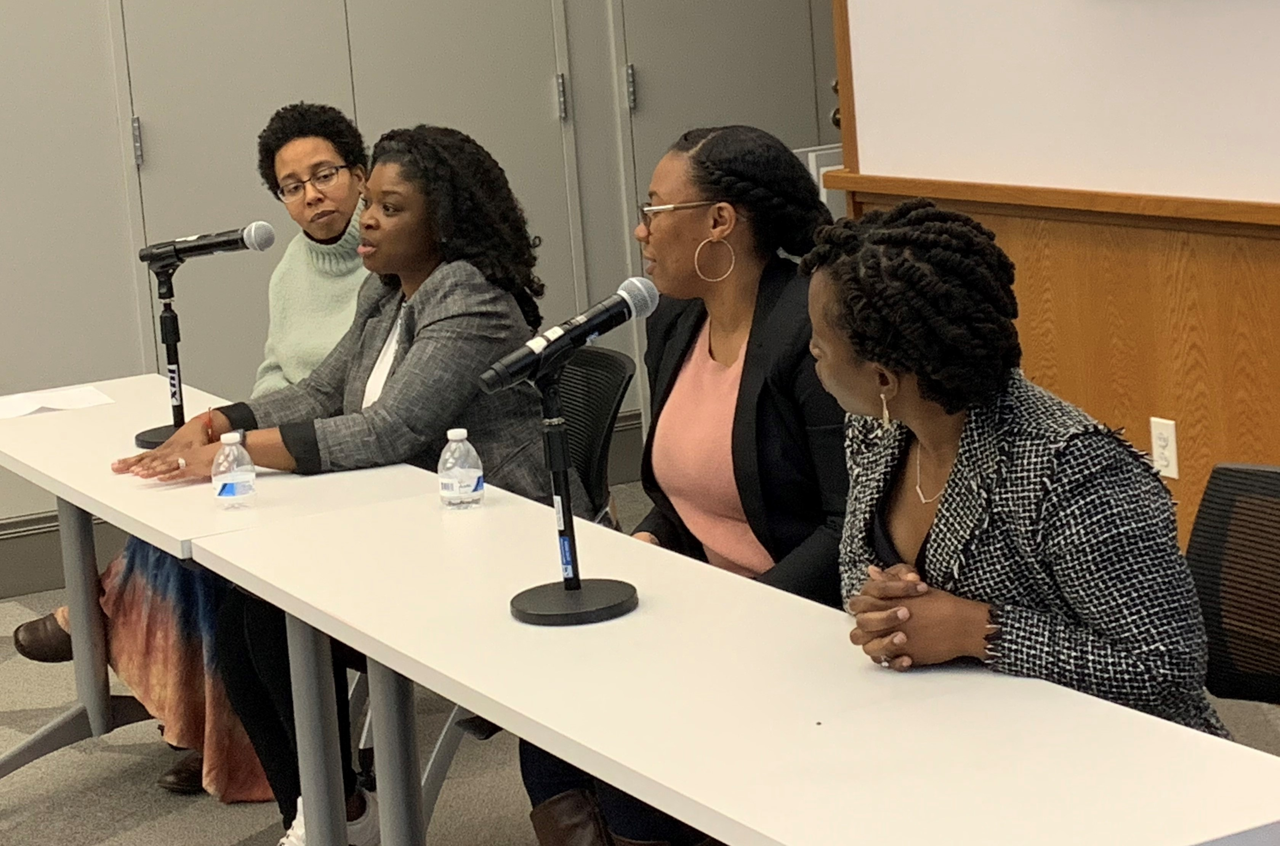
What took place?
In celebration of Black History Month, successful women in the STEM field shared their educational and career experiences with an audience of students, faculty and staff. The event was sponsored by the Committee for Diversity and Inclusion and the CCC Foundation.
The event took place yesterday in the Community Room.
Thanks in advance,
A.Marie Basche

