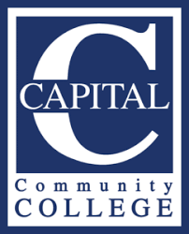
GRAPHIC DESIGN REQUEST PROCEDURE - Updated 9.10.2021
Send graphic design requests to BOTH Vivian Nabeta and Eric Campbell at vnabeta@capitalcc.edu and ecampbell@capitalcc.edu. We will review and provide an estimated completion date. For your planning purposes, please allow approximately 4 to 8 business days from the initial request date to when the job will be completed. More complicated requests will require a meeting for review and discussion. The design process can take a bit of time so the sooner you can submit your request, the better. Please note that requests that are incomplete or missing information will be delayed. In order to better process your request(s), we ask that you do the following:
- Inform us what design need(s) you have. For example:
  - Flyer
  - Postcard
  - Poster
  - Campus monitor display
  - Brochure/pamphlet
  - Banner
- Provide FINAL copy. Do not submit sample or placeholder copy. Doing that will slow down the completion of your project and will create extra work for Eric. If you need assistance creating or editing copy, please let Vivian know. For example, if you have an event. Please make sure that your final copy includes the event date, time, description, contact information, and registration information (if required).
- Submit follow up materials such as photos or relevant material along with your request. If you have more than one request, you may submit them all together. Photos should be high-resolution, if you do not have photos, the marketing team can find some for you.

If you have someone on your team that has graphic design experience and can create materials for you/your department, please contact Eric and Vivian and we can provide templates as well as schedule a training session.

