Have You Logged-In to Core-CT Lately?

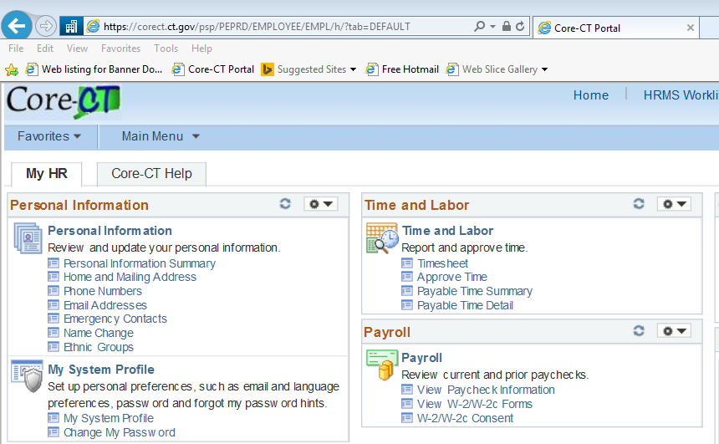
Your 2015 W-2 will be issued electronically in Core-CT in January

You must be able to Log-In to Core-CT in order to print it

Log-In to Core-CT by December 4th to be sure you will be able to view/print your W-2 in January

